1.1 ARRANGEMENTS

Solution Exercise – Easy

1. (b)

We get the below arrangement on basis of information given.

P2

P5

P7

P6

P4

P3

P1

2. (b)

The sitting arrangement is as follows:

T Q P R S

3. (a)

Shraddha Priyanka Anushka Pariniti Bipasha Deepika

**OR**

Deepika Bipasha Pariniti Anushka Priyanka Shraddha

**Solutions for 4** – **6:**

The cars are placed as follows

Scorpio Ciaz Verna Vento XUV Santro Ecosport

4. (c) ; 5. (d) ; 6. (c)

**Solutions for 7** – **10:**

The building are arranged as follows:

Millennium 2 tallest

Sky 1

Millennium 1

Cyber 1

Sky 2

Cyber 2 smallest

7. (c) ; 8. (b) ; 9. (d) ; 10. (c)

**Solutions for 11** – **14:**

On basis of the information we get the following arrangement:

F5 F9 F4 F3 F1 F6 F8 F7 F2

11. (a) ; 12. (d) ; 13. (d) ; 14. (b)

**Solutions for 15** – **19:**

On basis of the information we get the following arrangment:

|  |
| --- |
| Fiat |
| Bedford |
| Maruti |
| Ambassador |
| Fargo |
| Cadillac |
| Mercedes |

15. (a) ; 16. (b) ; 17. (d) ; 18. (a) ; 19. (c)

20. (a

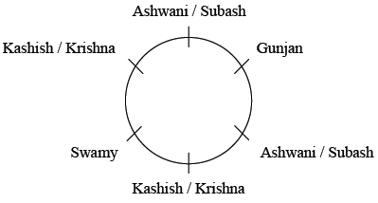

**Solutions for 21** – **25:**

On basis of the information we get the following sitting arrangment:

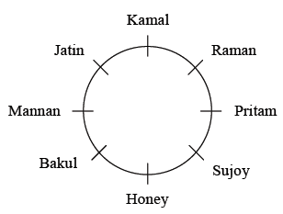

21. (d) ; 22. (d) ; 23. (a) ; 24. (c) ; 25. (a)

Solution Exercise – Medium

1. (c)

Orange White Yellow Green Red Blue

**OR**

Blue Red Green Yellow White Orange

**Solutions for 2** – **4:**

On basis of the information we get the following arrangement:

C/D E/F E/F B C/D A/G A/G

2. (c) ; 3. (d) ; 4. (d)

**Solutions for 5** – **7:**

On basis of the information the queue of doctors is as follows:

ENT Surgeon Eye Heart Ortho

5. (d) ; 6. (b) ; 7. (b)

8. (d)

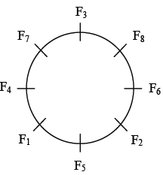

**OR**

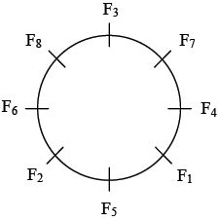

9. (b)

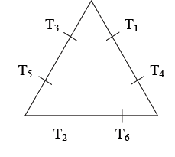

10. (a)

1 → Organizational Behavior

2 → Industrial Relations

3 → Organizational Behavior

4 → TOM

5 → Industrial Relations

6 → Industrial Relations

7 → TOM

8 → Economics

11. (a)

Rajni Anna Alaghri **↓** facing down.

Mount Hassan Ratan **↑** facing up.

**Solutions for 12** – **15:**

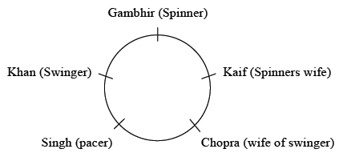

12. (d) ; 13. (a) ; 14. (a) ; 15. (d)

**Solutions for 16** – **20:**

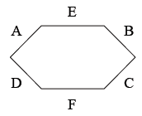

16. (c) ; 17. (a) ; 18. (c) ; 19. (a) ; 20. (b)

Solution Exercise – Difficult

**Solutions for 1** – **4:** On basis of the information given the office are placed as follows:

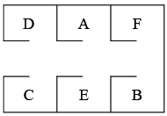

1. (c) ; 2. (d) ; 3. (a) ; 4. (b)

**Solutions for 5** – **8:** On basis of the information the plants can be stacked as follows:

Abelia – A, Berrya – B, Cadia – C, Danae – D, Echium – E, Ficus – F, Garrya – G, Haastiab – H

|  |  |  |  |  |  |  |  |  |
| --- | --- | --- | --- | --- | --- | --- | --- | --- |
| A | H | C | E | or | A | G | C | E |
| G | D | F | B | H | D | F | B |

5. (d) ; 6. (d) ; 7. (a) ; 8. (d)

**Solutions for 9** – **13:**

|  |  |  |  |  |
| --- | --- | --- | --- | --- |
| Media | Cricketer/Actor | VP | Actor/Cricketer | Gambler |
| 1301 | 1304 | 1309 | 1306 | 1303 |

|  |  |  |  |  |
| --- | --- | --- | --- | --- |
| Footballer | Lawyer | Doctor | Businessman | CEO |
| 1308 | 1305 | 1310 | 1307 | 1302 |

9. (b) ; 10. (c) ; 11. (d) ; 12. (a) ; 13. (d)

**Solutions for 14** – **17:**

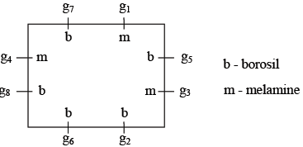

14. (c) ; 15. (a) ; 16. (b) ; 17. (c)

18. (d)

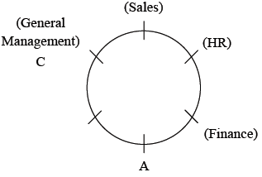

We cannot find the subject of A uniquely.

19. (b)

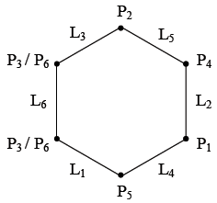

**Solutions for questions 20 to 22:**

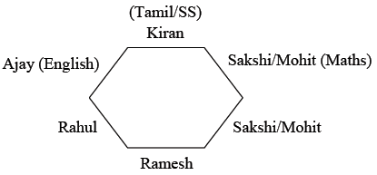

20. (c)

21. (a)

If Tamil is opposite to Social Studies.

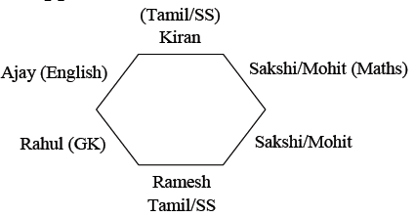

22. (d)

Accoding to additional conditions

Ajay → English

Rahul → Tamil

Ramesh/Kiran → Science, GK, SS

Sakshi/Mohit → Maths, Science, GK, SS

**Solutions for 23** – **27:**

We will get the 4 following cases.

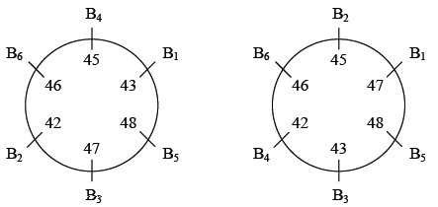

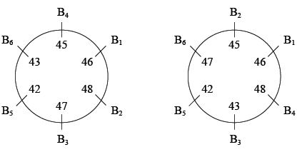

23. (d) ; 24. (a) ; 25. (b) ; 26. (c) ; 27. (a)

**Solutions for 28** – **32:**

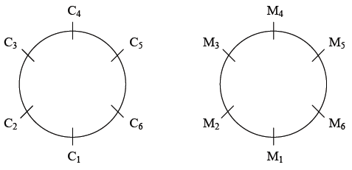

C2 → Tamil to Telgu

C3 → Telgu to Tamil

28. (c) ; 29. (b) ; 30. (b) ; 31. (b) ; 32. (a)

**Solutions for 33** – **37:**

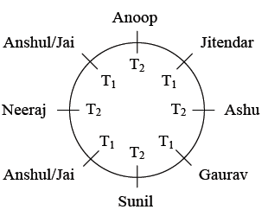

Team 1 → Anshul, Jai, Gaurav, Jitendar

Team 2 → Anoop, Ashu, Sunil, Neeraj

33. (d) ; 34. (c)

35. (a)

|  |  |
| --- | --- |
| Jai = 4*x* points | Anoop = *y* points |
| Gaurav = 12*x* points | Ashu = *y* + 14 |
| Anshul = 4*x* points | Sunil = *y* + 27 |
| Jitendar = *x* points | Neeraj = *y* + 39 |

Team 1 total = 2/*x*

Team 2 total = 4*y* + 80

*x* = 1 and *y* = 1

Team 1 = 21 × 1 = 21 points

∴ Team 2 = 4 × 1 + 80 = 84 points

36. (b)

Anshul/Jai = 4*x* = 28 points

⇒ *x* = 7 points

Team total = 21 × 7 = 147 points

Neeraj = *y* + 39 = 55

⇒ *y* = 16 points

Team 2 total = (16 × 4) + 80 = 144 points

37. (a)

Team 1 total = 21*x* = 105 points

*x* = 5 points

Jai = 20 points

Anshul = 20 points

Gaurav = 60 points

Jitendar = 5 points

Team 2 total = 4*y* + 80 = 92 points

*y* = 3 points

Anoop = 3

Ashu = 17

Sunil = 30

Neeraj = 42

**Solutions for 38** – **40:**

|  |  |  |
| --- | --- | --- |
| P (White) | U (Orange) | S (Red) |
| R (Yellow) | Q (Green) | T (Blue) |

Order of heights → T > S, Q > P > R > U

38. (c) ; 39. (d) ; 40. (b)